Week 5

A D 1 - A Use Case Diagram

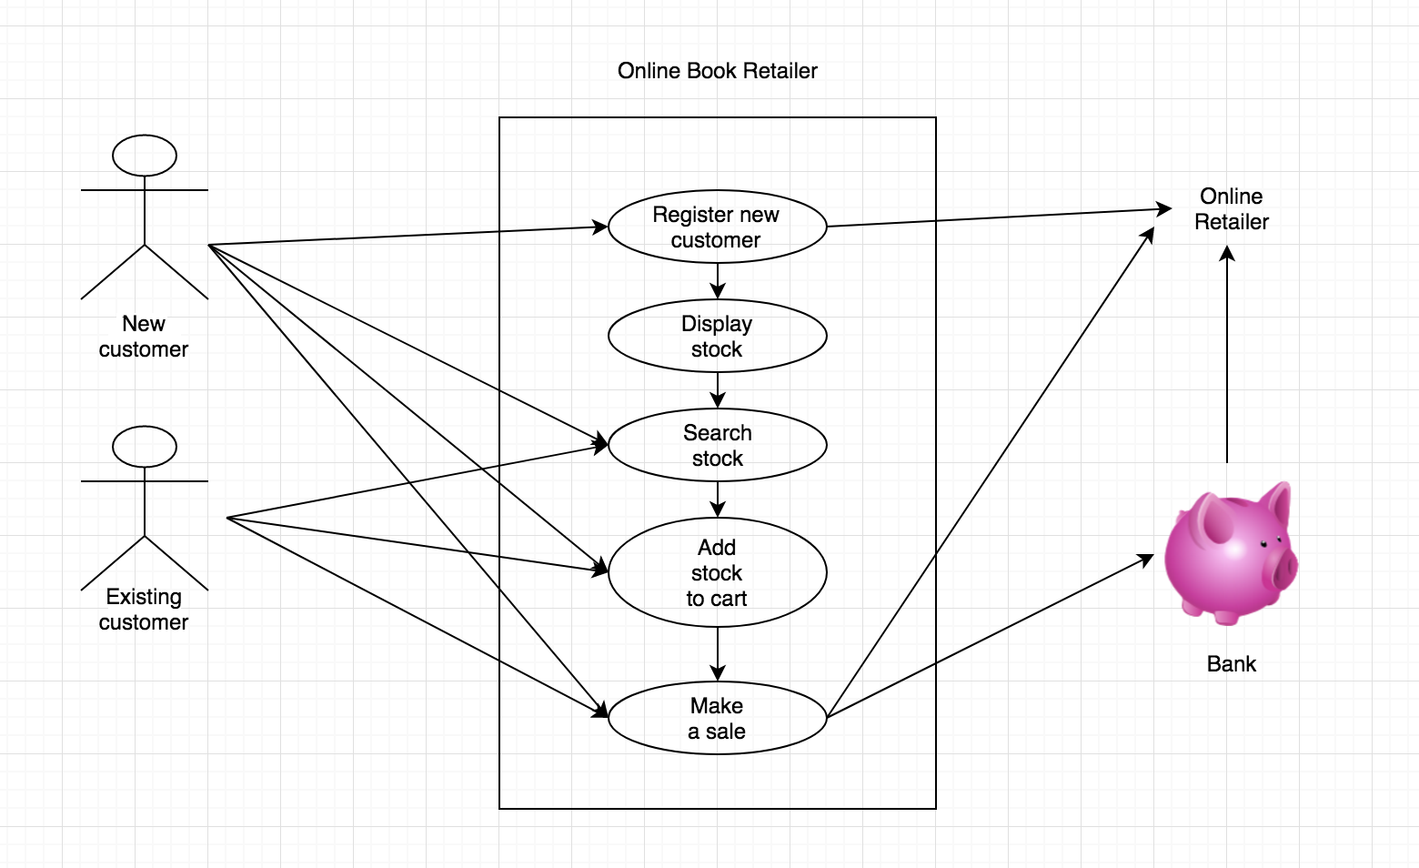

A D 2 - A Class Diagram

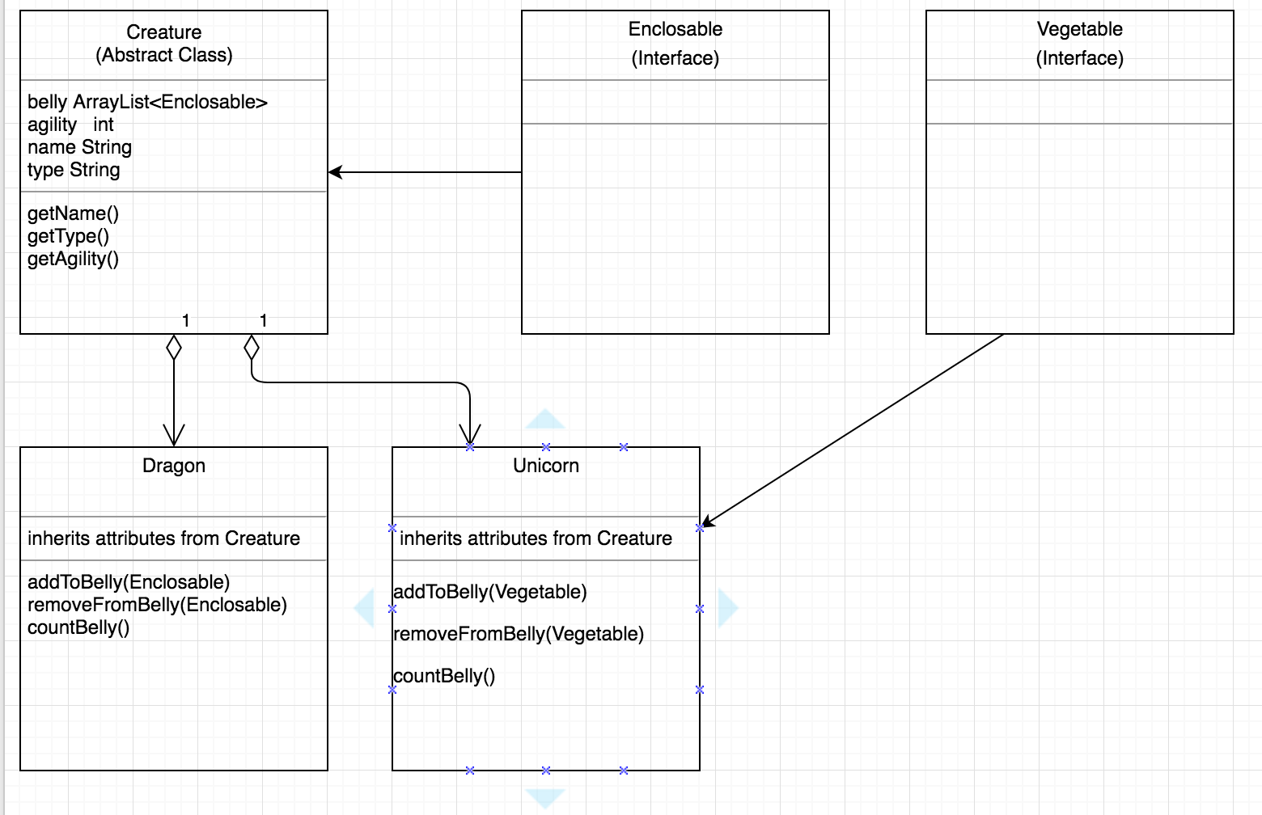

A D 3 - An Object Diagram

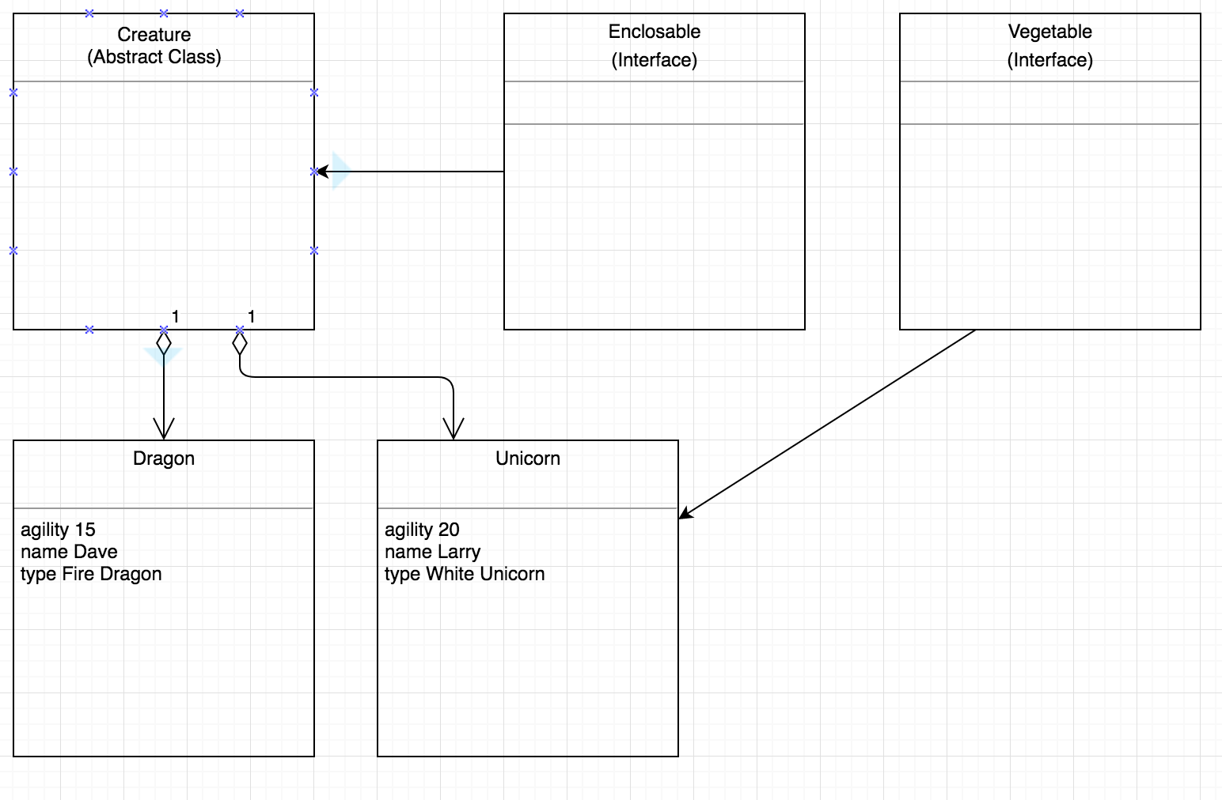

A D 4 - An Activity Diagram

